Health and Safety Policy Statement

Andrew Shepherd Construction Ltd recognises its statutory duty to comply with all relevant legislation and the duties and obligations resulting from them.

The Company is committed to the protection of its employees and others, including members of the public, from harm or loss resulting from the Company’s activities and undertakings. Adequate resources will be made available to ensure the success of this Policy.

The Company intends to strive for continual improvement in all areas of health, safety and welfare and to present themselves as an industry leader in the development of effective and practicable health and safety management systems.

To these ends, the implementation of this Policy aspires to achieve the following, so far as is reasonably practicable:

- suitable and sufficient risk assessments,
- implementation of identified control measures,
- the provision and maintenance of a safe and healthy working environment,
- the maintenance of safe systems of work,
- safety in the handling, transportation, etc of articles and substances,
- safe access to and egress from all workplaces
- the control or elimination of accidents and incidents which might result in any loss,
- adequate and comprehensible information, instruction and training,
- the provision and maintenance safe work equipment which is without health risks.
- that all employees give this policy their wholehearted support and co-operation,
- that employees at all levels adopt their personal responsibility for health and safety,
- full consultation between management, employees and any appointed safety representatives
- the protection from risk of all others who might be affected by Company operations.

The Company’s aim is to ensure the health and safety of its employee’s contractors and visitors through implementation of safe practices from all of its operations.

Signed by

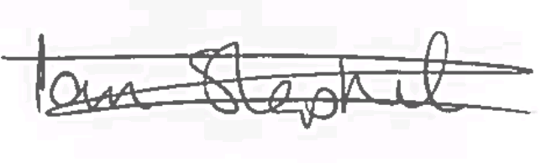

Ian Shepherd (Director)
Date: 06th March 2019

